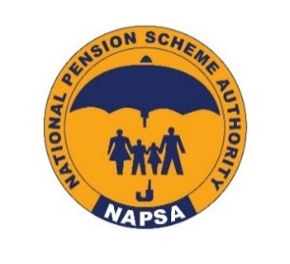

NATIONAL PENSION SCHEME AUTHORITY
INVITATION FOR BIDS
THREE-YEAR FRAMEWORK AGREEMENT FOR THE PROVISION OF CLEANING, LANDSCAPING, AND PEST CONTROL SERVICES TO VARIOUS NATIONAL PENSION SCHEME AUTHORITY (NAPSA) PROPERTIES, SUBJECT TO ANNUAL REVIEW AND POSSIBLE RENEWAL, BASED ON SATISFACTORY PERFORMANCE (NAPSA/DHRA/DI/ONB/01/26)
This tender has been invited by the National Pension Scheme Authority (NAPSA) through the Electronic Government Procurement System (e-GP system) platform.
The e-GP system is hosted by the Zambia Public Procurement Authority (ZPPA). Bidding will be conducted using the Open National Bidding (ONB) procedures specified in the Public Procurement Act No. 8 of 2020, the Public Procurement Act (Amendment) No. 17 of 2023 and the Public Procurement Regulations of 2022. The tender is open to all interested eligible Citizen and Local bidders. However, Local Bidders MUST partner with Citizen Bidders. Interested Bidders can access the Solicitation Document on the ZPPA website (www.zppa.org.zm) and NAPSA website (www.napsa.co.zm).
Submission of bids shall be through the e-GP system and no bid submitted outside the e-GP system shall be accepted.
Bidders should request for clarification on the tender requirements through the pre-bid meeting and the respective clarification section of the e-GP system before the deadline for requests for clarification indicated in the Solicitation Document.
The procurement schedule, subject to change, is as follows:
Floatation date: Wednesday, 1st April, 2026 at 12:00 hours (Zambian Time).
Pre-bid meeting: Tuesday, 14th April, 2026 at 10:00 hours (Zambian Time). The meeting will be held virtually through Microsoft Teams, and the meeting link will be shared through the solicitation document.
Tender closing: Monday, 4th May, 2026 at 10:30 hours (Zambian Time), through the e-GP system.

Secretary
Management Procurement Committee
For/Director General
NATIONAL PENSION SCHEME AUTHORITY
Issue Date: 1st April, 2026

